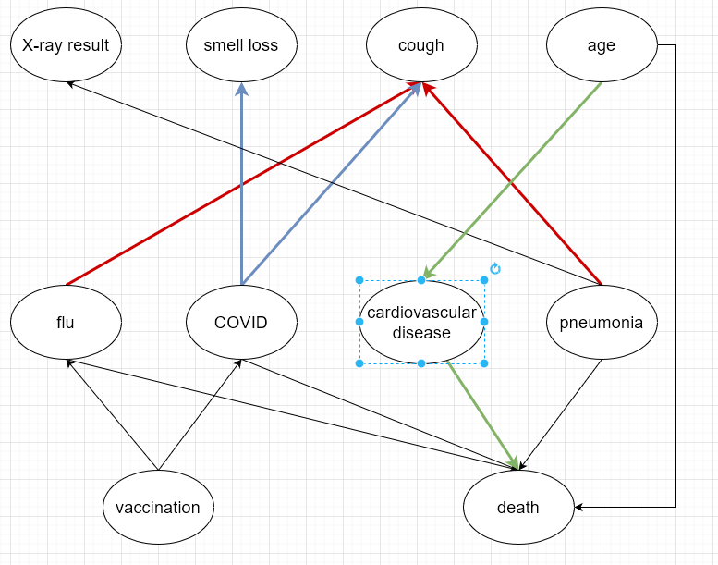

**Serial Connection A->B->C**

Updating our belief about A will also update our belief about C. However, if B is known, updating A will not influence C.

For example, Age->Cardiovascular Disease->Death is a serial connection. Knowing patient's age will influence our belief of him having cardiovascular disease and his probability of dying. However, when we know patient had cardiovascular disease, then knowing the age won't influence their probability of death. This is however not realistic - there may be other reasons for death especially due to old age. Thus, a connection Age->Death was also added.

**Diverging Connection A<-B->C**

Updating our belief about A will also update our belief about C and vice versa. However, if B is known, no evidence is transmitted.

For example, Smell loss <- COVID -> Cough is a diverging connection. If we don't know whether the patient has COVID, knowing about either of smell loss or cough will influence our belief about the patient having the other symptom. However, knowing that he/she has COVID, knowing about one of the symptoms will not update our belief about the other.

**Converging Connection A->B<-C**

Updating our belief about A will also update our belief about C and vice versa only if the state of B is known

For example, flu -> cough <- pneumonia is a converging connection.

If we know that patient has cough, we suspect both flu and pneumonia. If we learn that the patient has flu, it decreases our belief in him having pneumonia. However, if we don't know about the cough symptoms, knowing that the patient has flu does not influence our belief about him having pneumonia.

**Testing for D-Separation**

Let us choose two nodes far apart, say vaccination and pneumonia. We can trace 3 paths between them:  
1. vaccination->flu->cough<-pneumonia  
2. vaccination->COVID->cough<-pneumonia  
3. vaccination->COVID->death<-pneumonia

Lets assume we have no evidence of any nodes.

1. We can see that the flu->cough<-pneumonia path is a converging connection. Since cough node is not known, the connection is blocked.  
2. We can see that COVID->cough<-pneumonia is a converging connection.   
Since cough node is not known, the connection is blocked.  
3. We can see that COVID->death<-pneumonia is a converging connection.   
Since death node is not known, the connection is blocked.

In this case, the variables are d-separated. This confirms our expectations. With no prior information, vaccination and pneumonia have no influence on one another.

However, if we introduce evidence in the cough node, the variables cease to become d-separated. This makes sense, because if we observe cough, then we can suspect either flu or pneumonia or COVID. Knowing about the vaccination reduces our belief about COVID and flu, and thus increases our belief that the cough caused by pneumonia.